CAREERS FOR PEOPLE WITH GOOD COMMUNICATION SKILLS
Posted by Melissa Roux | Jan 27, 2017 | Career Tips and Advice, General | 2 |
“Good communication skills”, “interpersonal skills”, “effective oral and written communication skills” – you’re probably used to seeing these requirements in nearly every job advertisement you read. And yes, communication skills are important in every type of job you do. But some jobs are more dependent on communication than others.
In engineering careers, for example, you need to be able to communicate with a variety of stakeholders to make sure that the work is done properly. But you also need the right technical skills – and if you don’t have those, it won’t matter how good your communication skills are.
If communication is your strong point, and you’re looking for a career where you can use that strength to fulfil your key responsibilities, here are a few options to consider:

MARKETING AND PUBLIC RELATIONS (PR):
Most job opportunities in this field are heavily dependent on communication skills, as the main aim is to persuade others – either to buy a product or service, or to hold a certain opinion of something (or someone).

EXAMPLES OF COMMUNICATION-BASED ROLES IN THIS FIELD INCLUDE:
- Communications Officer>
- Copywriter
- Customer Service Representative
- Marketing Co-Ordinator
- PR Officer
- Press Secretary
- Social Media Manager

HUMAN RESOURCES (HR):
Since the HR department is responsible for managing employee relations, and for being the channel of communication between senior management and the employees within an organisation, communication skills are essential for working in this field.
HR personnel not only have to deal with disputes between employers and employees, but also have to communicate company policies, address grievances, recruit and train new employees, and maintain employee morale.

EXAMPLES OF COMMUNICATION-BASED ROLES IN THIS FIELD INCLUDE:
- Employee Relations Officer>
- HR Manager
- HR Officer
- Recruiter

CHILDCARE AND EDUCATION
Working in childcare and education is all about communication. Whether you are looking after children while their parents are at work, or whether you are teaching in a formal classroom environment, you need to be able to communicate with children in a way that they will understand. Not only that, but you also need to be willing and able to communicate with their parents.
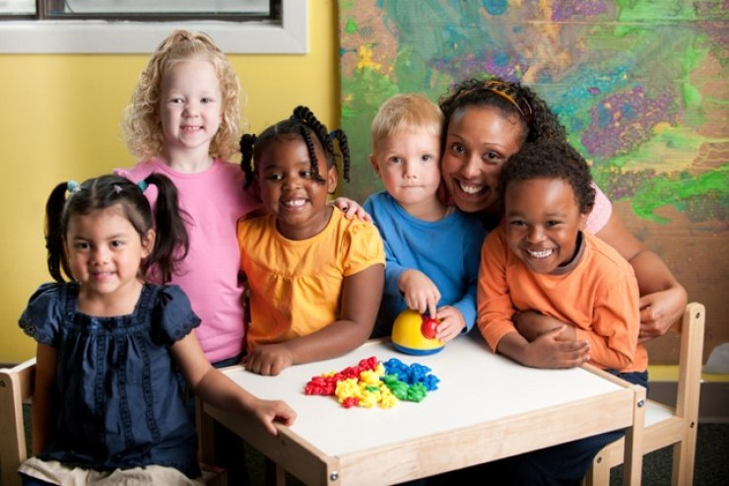

EXAMPLES OF ROLES IN THIS FIELD INCLUDE:
- Au Pair
- ECD Practitioner
- Exam Administrator
- Pre-School Teacher
- School Secretary
- Teacher
- Tutor

MEDIA
The media is not only responsible for delivering news and commentary on current affairs to the public, but is also responsible for shaping public opinion and upholding certain values, such as freedom of speech. Effective communication therefore plays a pivotal role.

EXAMPLES OF COMMUNICATION-BASED ROLES IN THIS FIELD INCLUDE:
- Editor
- Interpreter (if you are fluent in two or more languages)>
- Journalist
- News Reader
- Reporter
- Translator (if you are fluent in two or more languages)
- TV Presenter

OFFICE ADMINISTRATION AND MANAGEMENT
While it might not seem obvious at first, succeeding in this field is also dependent on strong communication skills.
Whether it’s taking instructions from your boss, greeting visitors, answering the phone, scheduling meetings, taking minutes, dealing with suppliers, making travel arrangements, or typing up reports, effective communication is essential. Just imagine what would happen if your boss asked you to book a trip to San Jose, California for a conference, and she discovered at the last minute that you booked a trip to San Jose, Costa Rica instead!

SOME EXAMPLES OF COMMUNICATION-BASED ROLES IN THIS FIELD INCLUDE:
- Office Manager
- Personal Assistant (PA)
- Receptionist
- Secretary
The roles listed above are only a few examples of the types of careers where good communication skills are a core requirement. There are many other careers where good communication skills are also essential.

SO WHAT DOES THE TERM “GOOD COMMUNICATION SKILLS” REALLY MEAN?
“Communication skills” is a broad term that refers to how you interact with other people, including how you convey messages to others and how you receive messages from others.
Generally speaking, someone is said to have good communication skills if they are able to convey messages in such a way that others are easily able to understand them, and if they are easily able to grasp the messages being conveyed by others. Communication skills don’t only refer to verbal communication, but also to non-verbal communication (e.g. body language, tone of voice, imagery).
Dale Carnegie courses
- Toastmasters programmes
- Oxbridge Academy courses:
  - Oxbridge Academy Short Course: Basics of Public Relations
  - Oxbridge Academy Skills Certificate: Principles of Public Relations
  - National Certificate: N4 Public Relations (SAQA ID 66879)
  - National Certificate: N5 Public Relations (SAQA ID 66958)
  - National Certificate: N6 Public Relations (SAQA ID 67003)

