How to Change Your Profile Picture in Schoology:
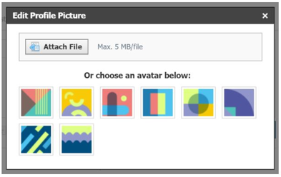
- Hover over the profile picture and click Edit Picture.
- If you already have a photo in place, click Remove Picture to remove your current picture from view.
- Click Attach File.
- Choose a JPEG, PNG, or GIF file from your device. There is a 5MB limit per photo file.

Please chose a picture that has good lighting, and is framed so I can easily see your face.
These are all great examples:

